Disability Leave Transactions

Decision Matrix – Short Term Disability (STD) (STD,Extend Leave, Return from Leave, Long Term Disability) 2
Entering Short Term Disability With and Without FMLA 3
Job Data 4
VCCS STD Bolt-on 5
Extend Leave 7
Job Data 7
STD Bolt-on for Leave Extension 8
Return from Leave 10
Job Data 10
Long Term Disability 10
Job Data 11

Decision Matrix – Short Term Disability (STD) (STD,Extend Leave, Return from Leave, Long Term Disability)
WHEN TO USE | ACTION | REASON |  | PMIS TRANSACTION
A classified or faculty employee is on VSDP without Workers' Comp and without FMLA. | Short Term Disability w Pay | STD with no WC and w/o FMLA |  | Triggers a PSE031, Short Term Disability with No Workers' Comp and without FMLA transaction to PMIS.
A classified or faculty employee is on VSDP without Workers' Comp and with FMLA. | Short Term Disability w Pay | STD with no WC and with FMLA |  | Triggers a PSE031, Short Term Disability with No Workers' Comp and with FMLA transaction to PMIS.
A classified or faculty employee is on VSDP with Workers' Comp and without FMLA. | Short Term Disability w Pay | STD with WC and w/o FMLA |  | Not currently interfaced
A classified or faculty employee is on VSDP with Workers' Comp and with FMLA. | Short Term Disability w Pay | STD with WC and with FMLA |  | Not currently interfaced
DECISION MATRIX – EXTEND LEAVE
WHEN TO USE | ACTION |  | REASON | PMIS TRANSACTION
A classified or faculty employee has been placed on STD. | Data Change |  | Leave Extension | Not currently interfaced.
FMLA eligibility has expired but STD leave is being extended. | Data Change |  | Remove FMLA and Extend Leave | Not currently interfaced
NOTE: Data on the STD bolt-on must be updated by adding a row and entering the revised data after the highest sequence #.
DECISION MATRIX – RETURN FROM LEAVE
A faculty employee is returning from STD. | Return from Leave |  | Return from Leave - Faculty | Triggers a PSE304, Return from Leave-Faculty transaction to PMIS
A classified or faculty employee is returning from STD. | Return from Leave |  | Return from STD | Triggers a PSE304, Return from Short Term disability transaction to PMIS
A classified or faculty employee is returning from Short Term Disability with work restrictions | Return from Leave |  | Return from STD w restrictions | Do not use. Not currently interfaced and no longer listed as an option in PMIS.
DECISION MATRIX – LONG TERM DISABILITY
WHEN TO USE | ACTION |  | REASON | PMIS TRANSACTION
A classified or faculty employee has exceeded the 6 months maximum for STD and is unable to return to work | Termination |  | Separation - LTD | Not interfaced
A classified or faculty employee has exceeded the 6 months maximum for STD and is placed on LTD but is able to work in some capacity | Long Term Disability with Pay |  | LTD Working | Not interfaced

Entering Short Term Disability With and Without FMLA
Employees enrolled in the Virginia Sickness and Disability program (VSDP) are eligible for Short Term Disability (STD) benefits based on the report provided by the Third Party Administrator (TPA) for the plan. The Action and Reason of with or without FMLA will determine the FMLA flag sent to PMIS. Completion of the FMLA pages in HRMS is optional.
The following transactions can be entered into HRMS to place an employee on Short Term Disability (STD). Data entered for STD is obtained from the Daily Action Report (DAR) provided by the Third Party Administrator (TPA).
NOTE: The TPA changed in May of 2015 and STD reports will no longer be provided in paper format and must be accessed on-line. Field names on the report provided by the new TPA may be differ from previous field names on the prior reports. This document has been revised to accommodate the new field names but the process remains the same.
For reference, see memorandum dated June 23, 2015 from Anne Waring to Executive HR Directors)
NOTE: Transactions for STD with Workers’ Compensation must be entered into HRMS but are not currently interfaced to PMIS.
Action | Reason | Interface
Short Term Disability w Pay | STD with No WC and w/o FMLA | Sends PSE031 to PMIS
Short Term Disability w Pay | STD with No WC and with FMLA | Sends PSE031 to PMIS
Short Term Disability w Pay | STD with WC and w/o FMLA | Not currently interfaced
Short Term Disability w Pay | STD with WC and with FMLA | Not currently interfaced

Job Data
NAVIGATION: Workforce Administration>Job Information>Job Data>Work Location
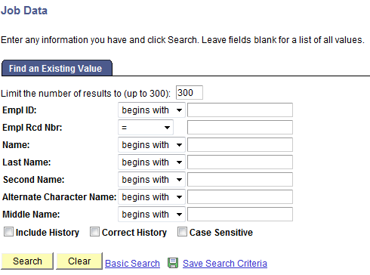
Enter the Empl ID of the employee going on disability
Click SEARCH
On the Work Location tab
Click + to Add a Row
- Effective Date - Enter Disability Start Date from the Daily Action Report (DAR) Report. This date excludes the 7 calendar day waiting period. (This was previously the Benefit Start Date). This date must be the same as the Disability Start Date on the report. The Benefits Start Date on the DAR is the day Payments begin.
- Action – Choose from dropdown (STD with Pay)
- Reason – Choose from dropdown. Required to trigger a transaction to PMIS.
- Expected Return Date – Enter the Estimated RTW Date from the DAR Report. (This was previously the Authorized End Date). If an Estimated Return Date is not on the DAR, enter next business day. This is a required field. Failure to enter a data in this field will prevent your transaction from interfacing to PMIS.
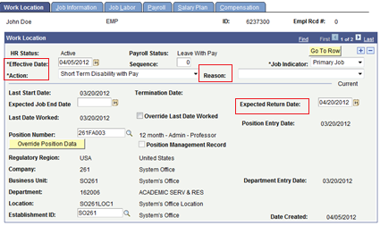
SAVE
Go to Short Term Disability bolt-on

VCCS STD Bolt-on
This page must be completed for the STD transactions to interface to PMIS.
NAVIGATION: VCCS HRMS>Human Resource>Short-Term Disability
- EmplID – Enter EmplID of the Employee on STD
Click SEARCH
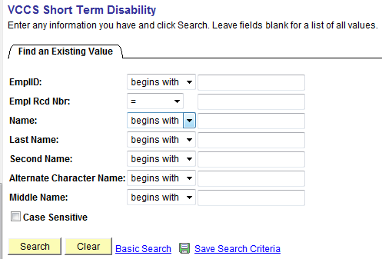
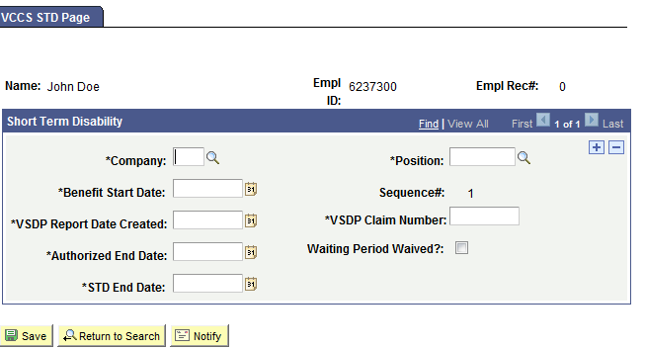
- Name – Defaults
- EmplID – Defaults
- Empl Rec# - Defaults
- Company – Enter 3 digit agency code
- Position – Enter the position number of the employee on STD
- Benefits Start Date – Enter Disability Start Date from DAR report. (This was previously the Benefit Start Date) Date should be the same as the Effective Date on Job Data.
- Sequence # - Defaults. If additional rows are added, Sequence # will increase if the row is added after the highest sequence.
- VSDP Report Date Created- This should be the Execution Time indicated on the on-line report.
- VSDP Claim Number – Enter first 10 digits of the Leave ID from DAR report
- Authorized End Date –Enter the Benefit End Date from the DAR report. (This was previously the Authorized End Date)
- Waiting Period Waived? – Use only if indicated on DAR report.
- STD End Date –Enter the Projected STD Max Date from DAR report. (This was previously the STD End Date) This is usually 26 weeks from the Disability Start Date. This date can be calculated manually if not on the report. This date indicates the maximum period the employee may be on STD.
SAVE
NOTE: If the dates for STD should change based on additional DARs, the data on the bolt-on must also be updated. To add additional rows, navigate to the highest sequence number, click the + sign to add a row then enter the new data. To determine the highest sequence number, click View All at the top of the page. Refer to steps above for the STD Bolt-on.
Note: An employee may have more than one STD claim, but not at the same time.

Extend Leave
Leave Extension for Short Term Disability is not currently interfaced to PMIS. Check PMIS to make sure the STD (PSE031) transaction is in PMIS prior to entering the Leave Extension. Although this transaction does not extend STD, the Leave Extension must still be keyed into HRMS and also into PMIS to maintain consistency between the two systems.
Action | Reason | PMIS
Data Change | Leave Extension | Not currently interfaced for STD.
Data Change | Remove FMLA and/or Extend Leave | Not currently interfaced.

Job Data
NAVIGATION: Workforce Administration>Job Information>Job Data
Enter EmplID of the employee whose leave will be extended.
Click Search
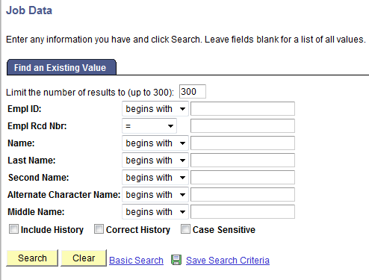
Add a row by clicking the + sign.
- Enter data on the Work Location tab
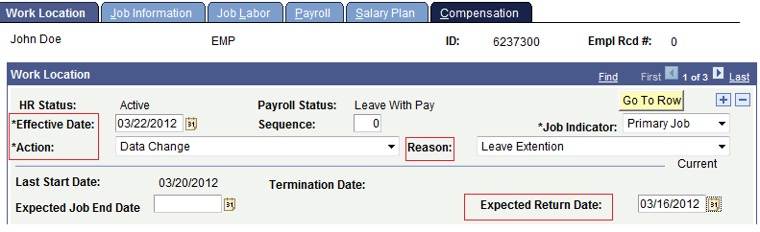
- Effective Date – The date should be the date that was entered in the Expected Return Date field when the employee was placed on STD.
- Action – Choose Data Change
- Reason – Choose Leave Extension
- Expected Return Date – Enter Estimated RTW Date from DAR documentation or the date that was entered in the Expected Return Date field when the employee was placed on STD. Failure to enter a date in this field will prevent your transaction from interfacing.
SAVE

STD Bolt-on for Leave Extension
This step assumes the STD bolt-on was completed when the employee was placed on leave.
NAVIGATION: VCCS HRMS Menu>Human Resources>Short Term Disability
Enter EmplID of the employee whose STD is being extended.
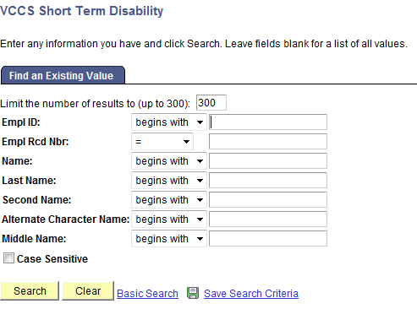
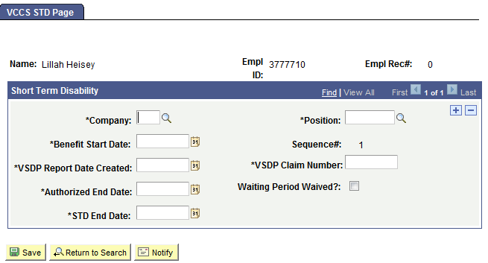
Add a Row by clicking the (+) sign
NOTE: There may be multiple rows on the STD bolt-on. When adding a row, make sure you are adding the row after the latest sequence #. Click View All to see all rows on the STD bolt-on.
- Company – Enter your agency’s 3-digit code
- Position – Enter the position # of the person on STD
- Benefit Start Date – Enter the original Disability Start Date of the STD
- VSDP Report Date Created- Enter the Execution Time from the on-line report for the Leave Extension.
- VSDP Claim Number – Enter the first 10 digits of the Leave ID number (should be same as prior row if same claim)
- Authorized End Date – Enter Benefit End Date from the DAR report.
- Waiting Period Waived? – Enter only if indicated on DAR report.
- STD End Date – Enter the Projected STD Max Date from DAR report. This date should be the same as the previous date since it represents the maximum 26 weeks of STD for which an employee is eligible.
SAVE

Return from Leave
These transactions return salaried employees from all types of leave. Entered correctly, the transaction will trigger a PSE304 to PMIS. The employee must have been placed on leave prior to returning from leave. Make sure prior STD (PSE031) and Leave Extensions (PSE033) transactions have interfaced to PMIS. Return from Leave does not need to be added to the bolt-on, only Job Data.
Action | Reason | PMIS
Return from Leave | Return from STD | Triggers a PSE304
Return from Leave | Return from VSDP LTD | Triggers a PSE304 Not currently interfaced
Return from Leave | Return from STD w Restrictions | Don’t use. No longer an option in PMIS

Job Data
NAVIGATION: Workforce Administration>Job Information>Work Location
Click the (+) sign to Add a Row
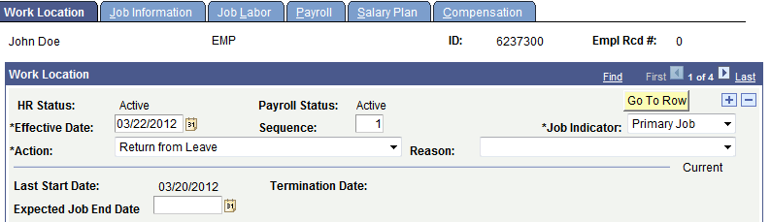
- Effective Date – Enter Expected Return Date that was entered when the employee was placed on leave or the date the employee actually returns.
- Action – Choose Return from Leave
- Reason – Choose Return from STD. Do not use Return from STD with Restrictions as this is no longer an option in PMIS.
SAVE

Long Term Disability
The transactions are for an employee whose Short Term Disability (STD) has expired (reached the 26 weeks of STD for which they are entitled) and are moving to Long Term Disability (LTD). The information to enter into fields is found from the DAR. Only two LTD actions will be maintained in HRMS and all must be entered into PMIS. No LTD transactions are interfaced to PMIS and must be manually entered.

Action | Reason | PMIS Transaction
Long Term Disability w Pay | LTD Working | Not interfaced
Termination | Separation, LTD | Not interfaced

The following transactions must be entered into PMIS and HRMS
Action | Reason
LTD with Pay | Not Working-No Workers Comp
LTD with Pay | VSDP No Workers Comp
LTD with Pay | VSDP Workers Comp
LTD with Pay | Working with Workers Comp
Termination | PSE139 Separation-LTD
Return from Disability | Return from VSDP LTD

Job Data
NAVIGATION: Workforce Administration>Job Information>Job Data
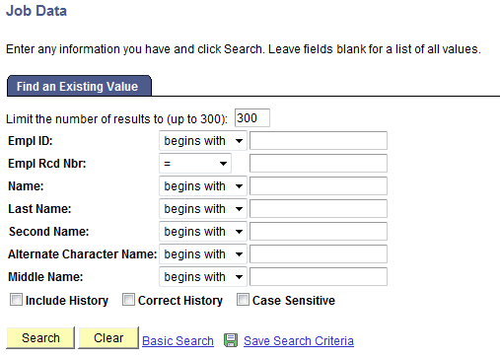
EmplID – Enter the ID of the person moving to LTD
Click SEARCH
Add a Row
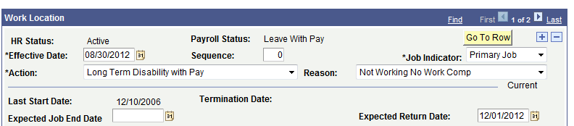
- Effective Date – Enter the “From” date on the approved line of the DAR
- Action – Choose LTD with Pay
- Reason – Choose from dropdown
- Expected Return Date –Enter Date after “Through” date from DAR report
SAVE
NOTE: Time Reporter Data may need to be inactivated based on reason.
If employee is being Terminated due to Long Term Disability enter the following:
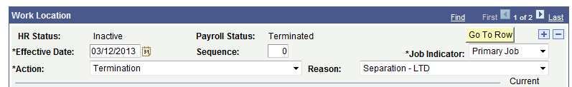
SAVE

