MEMORANDUM:

To: Vice Presidents of Financial and Administrative Services

From: Randy Ellis
VCCS Controller

Date: August 2022

Subject: Cardinal HCM Deductions Guidance

All,

As the “Go-Live” date for the Cardinal HCM Project is fast approaching, several questions have been raised regarding the payment of various payroll-related withholding and deduction items. Certain out-of-state taxes and other third-party Vendor payments will be processed through Accounts Payable by the agency instead of directly from Payroll. Liability accounts will be created for agencies to process payments from and will need to be reconciled. The System Office has met with the SSC Payroll and Accounts Payable team and would like to provide the following information.

Cardinal Reports will be processed either by SSC Payroll or the Agency, depending on who is processing the payroll. Reports will be available after payroll confirmation for each pay period which includes biweekly, semimonthly, and off cycles if applicable. SSC Payroll will process these reports for their agencies as part of the Post Payroll process each pay period and save these reports in the Agency’s PSDATA drive.

Process Pay Period Out-of-State Taxes

Cardinal Payroll Report RPY174 is the Tax Remittance Report that will provide the amount and other details to be paid to states and localities manually via Accounts Payable.

DOA automatically pays taxes for the following: VA, DC, MD, WV, KY

- All other states and localities on the RPY174 report will require agencies to submit a non-PO Voucher for each state and locality that requires payment. This cannot be submitted until the liability has been posted. Checks will be sent to each agency which is the same payment method as today. This is an Xbatch in AIS. The agencies will be responsible for how they remit payments to the states, whether it will be through PCards, ACH, or simply mailing the paper check.

- Vendors must be set up in both Cardinal and AIS. Each agency needs to confirm before submitting voucher requests.
Process Pay Period Non-Tax Payments

Cardinal Payroll Report RPY146 is the COVA Deduction Register Report that lists employees who have any deductions subtracted from their pay.

Additional deductions will require agency action. Any deductions that create a liability will require a non-PO voucher to be created. Please see page 213 of the PY381 Agency Payroll Management job aid:
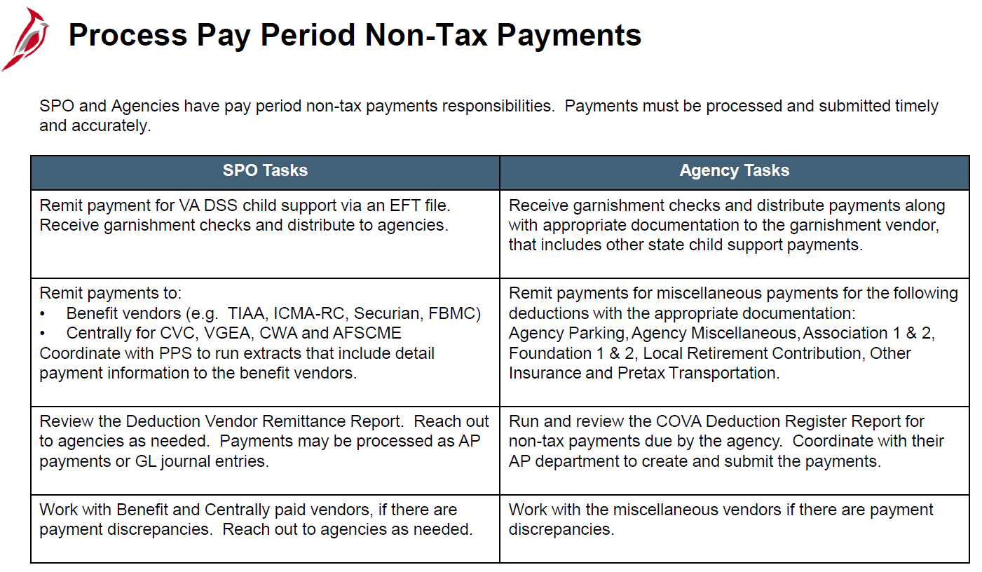

The following VCCS deductions have been identified as needing a non-PO Voucher to be created. Please note each agency is responsible for reviewing their COVA deduction registers to determine if an action is required on their part.

 | Deduction Name
 | ACAC |  | INSTADV/UNUM
 | ASSOC 1 |  | PARKING
 | BR FITNESS CTR |  | PDCCC FOUNDATI
 | DUE AGY |  | PETTYCSH
 | EDUFOUND |  | SAL ADV
 | EMPASOC1 |  | SCHLFUND
 | EMPASOC2 |  | UNUM LTD
 | FOUNDAT |  | UNUM LTD*
 | FOUNDT2

