Cardinal Impact Guide:

Finance

September 2022
Table of Contents
General Ledger Integration 3
FI01: Payroll Liability Account Reconciliation 3
Accounts Payable Integration 4
FI02: Employee Profile Sync Between HCM and Expense Module 4
FI03: HCM Supplier Voucher Process 5
FI04: Summarized HCM Voucher Accounting Data 5
FI05: Login Credentials new 6
General Finance and Cardinal Links 7
Appendix A: HCM Supplier Voucher Process 8

General Ledger Integration

FI01: Payroll Liability Account Reconciliation
Who is impacted?
Payroll Administrators
Process Change:
In Cardinal, the payroll activity recorded in the payroll journal includes liability accounts that should be cleared by voucher processing and central agency GL journals. Any deductions that create a liability will require a non-PO voucher to be created.
The following VCCS deductions have been identified as needing a non-PO Voucher to be created. Please note each agency is responsible for reviewing their COVA deduction registers to determine if an action is required on their part.

 | Deduction Name
 | ACAC |  | INSTADV/UNUM
 | ASSOC 1 |  | PARKING
 | BR FITNESS CTR |  | PDCCC FOUNDATI
 | DUE AGY |  | PETTYCSH
 | EDUFOUND |  | SAL ADV
 | EMPASOC1 |  | SCHLFUND
 | EMPASOC2 |  | UNUM LTD
 | FOUNDAT |  | UNUM LTD*
 | FOUNDT2

VCCS Impact:
Agencies will be responsible for reconciling the payroll liability accounts.
Resources:
Please see page 213 of the PY381 Agency Payroll Management job aid

Accounts Payable Integration

FI02: Employee Profile Sync Between HCM and Expense Module
Who is impacted?
Accounts Payable Administration
Process Change:
In Cardinal, Expense module employee profile information (excluding default ChartField values and user preferences) will sync from HCM.
VCCS Impact:
Agencies will no longer have to create employee profiles in the Expense module.
Agencies will only be able to create and maintain the optional default ChartField values and user preferences in the Expense module.
Resources:
SW AP315: Employee Profile Interface Processing
SW AP316 Creating and Updating an Employee Profile

FI03: HCM Supplier Voucher Process
Who is impacted?
Accounts Payable Administration
Process Change:
Payments to HCM suppliers for miscellaneous deductions and state and local withholding taxes (excluding Virginia, Maryland, and West Virginia) will now be processed through AP by the line agency. Agencies should select the appropriate supplier record designated with the HCM supplier classification for these payments to bypass debt setoff and payment cash checking.
Only voucher processors with a special role will be able to use HCM suppliers on vouchers, and only online.
VCCS Impact:
In Cardinal FIN, voucher processors will process payments to HCM suppliers. Agencies can use the new payment handling code (PY) for these payments, ensuring related checks will be distributed by Treasury with other AP-related attachment checks.
SPO will coordinate with CVG to establish HCM suppliers in Cardinal FIN.
Resources:
See Appendix A for VCCS Notification
Reports Catalog - Specifically RPY146 and RPY174

FI04: Summarized HCM Voucher Accounting Data
Who is impacted?
Payroll Administration
Process Change:
Accounts Payable Business Unit (AP BU) 99701 will be used for centralized HCM voucher processing (e.g., CVC deductions, deferred compensation) by SPO.
VCCS Impact:
No Impact to VCCS at this time.

FI05: Login Credentials new
Who is impacted?
All Finance Users
Process Change:
All Finance users will be required to start using their MyVCCS credentials with Cardinal Finance starting October 3, 2022.
Resources:
Cardinal Instructions will be emailed separately.

General Finance and Cardinal Links
https://www.cardinalproject.virginia.gov/finwbt - NAV220: Introduction to Cardinal Financial Reporting
https://www.cardinalproject.virginia.gov/job-aids - When using this website, please pay attention to the modules and applications to avoid confusion.
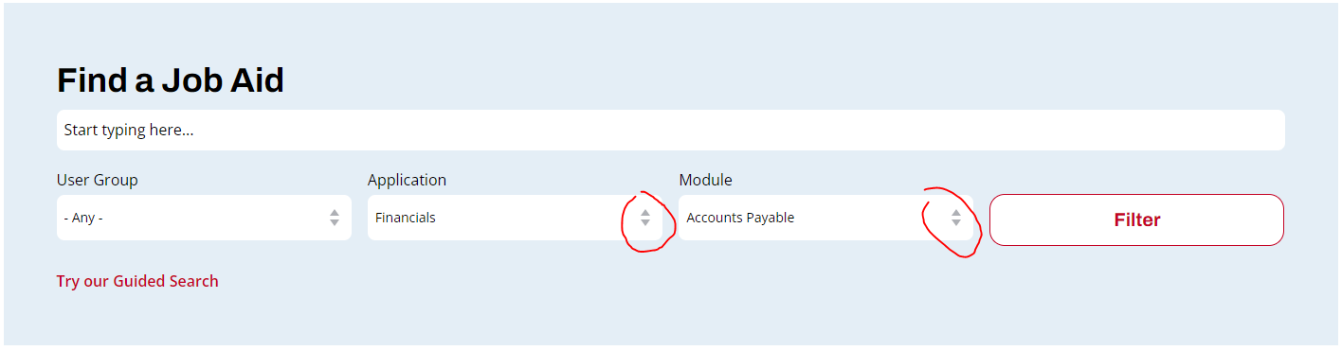

Appendix A: HCM Supplier Voucher Process
To: Vice Presidents of Financial and Administrative Services
From: Randy Ellis
VCCS Controller
Date: August 2022
Subject: Cardinal HCM Deductions Guidance
All,
As the “Go-Live” date for the Cardinal HCM Project is fast approaching, several questions have been raised regarding the payment of various payroll-related withholding and deduction items. Certain out-of-state taxes and other third-party Vendor payments will be processed through Accounts Payable by the agency instead of directly from Payroll. Liability accounts will be created for agencies to process payments from and will need to be reconciled. The System Office has met with the SSC Payroll and Accounts Payable team and would like to provide the following information.
Cardinal Reports will be processed either by SSC Payroll or the Agency, depending on who is processing the payroll. Reports will be available after payroll confirmation for each pay period which includes biweekly, semimonthly, and off cycles if applicable. SSC Payroll will process these reports for their agencies as part of the Post Payroll process each pay period and save these reports in the Agency’s PSDATA drive.
Process Pay Period Out-of-State Taxes
Cardinal Payroll Report RPY174 is the Tax Remittance Report that will provide the amount and other details to be paid to states and localities manually via Accounts Payable.
DOA automatically pays taxes for the following: VA, DC, MD, WV, KY
- All other states and localities on the RPY174 report will require agencies to submit a non-PO Voucher for each state and locality that requires payment. This cannot be submitted until the liability has been posted. Checks will be sent to each agency which is the same payment method as today. This is an Xbatch in AIS. The agencies will be responsible for how they remit payments to the states, whether it will be through PCards, ACH, or simply mailing the paper check.
- Vendors must be set up in both Cardinal and AIS. Each agency needs to confirm before submitting voucher requests.
Process Pay Period Non-Tax Payments
Cardinal Payroll Report RPY146 is the COVA Deduction Register Report that lists employees who have any deductions subtracted from their pay.
Additional deductions will require agency action. Any deductions that create a liability will require a non-PO voucher to be created. Please see page 213 of the PY381 Agency Payroll Management job aid:
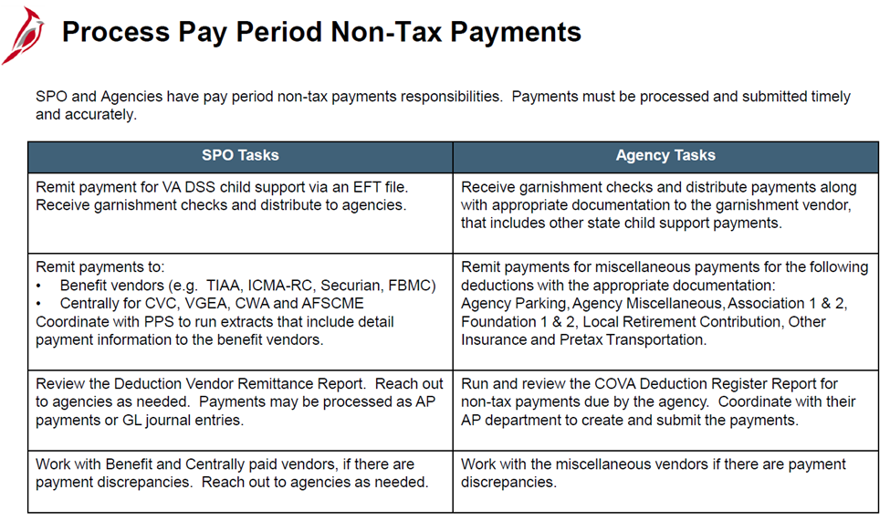
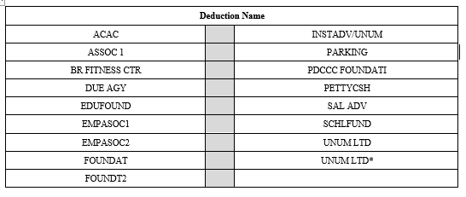
The following VCCS deductions have been identified as needing a non-PO Voucher to be created. Please note each agency is responsible for reviewing their COVA deduction registers to determine if an action is required on their part.

